Pallium India joins International palliative care organizations to urge governments to ensure balanced access to opioids for pain relief.
2017 February 28
1 Comment
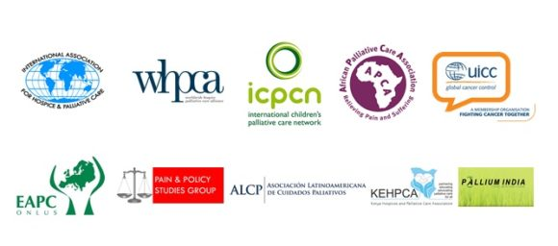
Pallium India has joined nine palliative care organizations from around the world to promote the safe and balanced use of opioids – drugs that act on the nervous system to relieve pain.
The “Access to Controlled Substances for Medical and Scientific Purposes: Ensuring and Restoring Balance” statement asks governments to ensure access to opioids for medical and scientific purposes and to reduce their abuse.
This comes as India’s medical and legal fraternity continues to wrangle over the controversial subject and data compiled by the National Crime Records Bureau (NCRB) showing that 26,426 suffering from various ailments, including cancer, AIDS and paralysis, chose to end their lives in 2013. The data also shows an increase in the number of suicides by people with cancer, with most patients losing their will to live following setbacks during diagnosis or relapse.
Though India had amended its Narcotic Drugs and Psychotropic Substances Act (NDPS) as early as in 2014 in order to make opioids available for pain relief and preventing misuse, 29 state governments have not ratified it, and hence not implemented.
Severe under-treatment of pain is reported in more than 150 countries, accounting for about 75 per cent of the world’s population. At least 5 billion people live in countries affected by the crisis of under consumption, and more than 18 million annually die with treatable pain. Global studies show that up to 84 per cent of patients suffer from pain due to cancer, HIV and other conditions.
Access for pain treatment and palliative care is lacking in several countries, mainly in Asia, the Gulf States, Africa and Latin America), while diversion and abuse is prevalent in high consumption countries of North America.
According to the World Health Organization (WHO), governments should strengthen measures, in collaboration with the WHO, to ensure that pharmaceutical companies do not unduly influence policy makers and health professionals with financial interests in opioid production and marketing. They should ensure collaboration between global, regional, and national pain and palliative care organizations to train healthcare providers to prescribe opioids safely for the treatment of pain.
Besides Pallium India, the other collaborating organisations to the statement are the International Association for Hospice and Palliative Care (IAHPC), Worldwide Hospice Palliative Care Alliance (WPCA), International Children’s Palliative Care Network (ICPCN), African Palliative Care Association (APCA), Union for International Cancer Control (UICC), European Association for Palliative Care (EAPC), Pain and Policy Studies Group (PPSG), Kenya Hospices and Palliative Care Association (KEHPCA).
According to the statement, to ensure and restore balance, governments across the world should evaluate their drug control systems for balance, using the WHO Ensuring Balance in National Policies on Controlled Substances guidelines, and follow recommendations for it.
They should implement, in collaboration with WHO, INCB, and UNODC, the recommendations from the WHO Palliative Care Resolution 67/19 and the UNGASS 2016 Outcome Document on the safe and effective use of controlled medicines for pain and palliative care, including enhanced data collection mechanisms throughout the controlled medicines supply chain to better detect diversion in real time.

